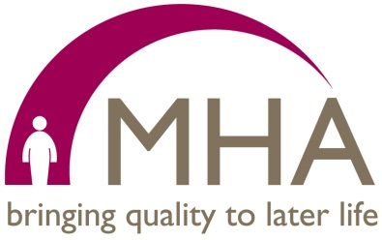
Thank you to all the churches who have supported MHA Sunday this year, raised awareness or raised funds in anyway. It is not too late to hold a service and there are resources to help with this on our website www.mha.org.uk/mhasunday.
We had a great time at Methodist Conference this year. We were pleased to give away our resources including a new pastoral visitors' guide for those who visit people living with dementia and a new worship resource, ‘Biblical Yoga’.
A highlight of Conference was the signing of the Expression of Commitment between the Methodist Church and MHA by Jill Baker, Chair of Trustees of the Methodist Council, and John Robinson CBE, Chair of Trustees for MHA. The Expression of Commitment states that both organisations will work together to:
- Explore ways of offering support to older people and develop initiatives to share with others as examples of best practice
- Look for opportunities to work closer in areas such as joint research around issues affecting older people
- Use their shared voices to encourage people in positions of power and influence to consider the needs of older people
During October and November we will be hosting WELL (Worship Engagement in Later Life) events in six locations (Cambridge, Bristol, Birmingham, Pinner, Leeds and Penrith). The training is for all those involved in pastoral visiting or helping to lead worship for people in later life, either in a church, community or care home setting. The event reflects MHA’s mission to help improve the quality of life for older people and is provided free of charge. To book please contact Georgina Fearon at chaplaincypa@mha.org.uk or telephone 01332 221922.
We are also delighted to be holding our Inaugural Walter Hall Lecture on the evening of 23 October 2019 at Methodist Central Hall, Westminster. The Rt Hon Lord David Willetts will be speaking on intergenerational responsibility, especially in the area of funding and support in later life. More details are available at www.mha.org.uk/lectures or by contacting chaplaincypa@mha.org.uk

Lesley France
Faith Communities Fundraising Co-ordinator

